**Bridge in Computer Network:**

A bridge in a computer network is a device used to connect multiple LANs together with a larger Local Area Network (LAN). The mechanism of network aggregation is known as bridging. The bridge is a physical or hardware device but operates at the OSI model’s data link layer and is also known as a layer of two switches.

The primary responsibility of a switch is to examine the incoming traffic and determine whether to filter or forward it. Basically, a bridge in computer networks is used to divide network connections into sections, now each section has separate bandwidth and a separate collision domain. Here bridge is used to improve network performance.

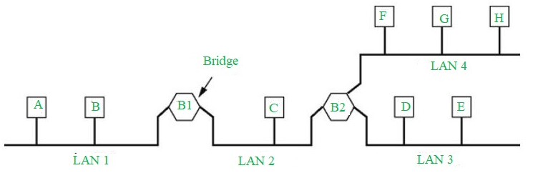

Functions of Bridges in the Network

The bridge is used to divide LANs into multiple segments.

To control the traffic in the network.

It can interconnect two LANs with a similar protocols.

It can filter the data based on destination/MAC address.

**Uses of Switch**

Switches are networking devices operating at layer 2 or a data link layer of the OSI model. They connect devices in a network and use packet switching to send, receive or forward data packets or data frames over the network.

A switch has many ports, to which computers are plugged in. When a data frame arrives at any port of a network switch, it examines the destination address, performs necessary checks and sends the frame to the corresponding device(s).It supports unicast, multicast as well as broadcast communications.

Features of Switches

* A switch operates in the layer 2, i.e. data link layer of the OSI model.
* It is an intelligent network device that can be conceived as a multiport network bridge.
* It uses MAC addresses (addresses of medium access control sublayer) to send data packets to selected destination ports.
* It uses packet switching technique to receive and forward data packets from the source to the destination device.
* It is supports unicast (one-to-one), multicast (one-to-many) and broadcast (one-to-all) communications.
* Transmission mode is full duplex, i.e. communication in the channel occurs in both the directions at the same time. Due to this, collisions do not occur.
* Switches are active devices, equipped with network software and network management capabilities.
* Switches can perform some error checking before forwarding data to the destined port.
* The number of ports is higher – 24/48.

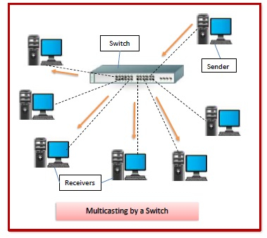

**How network hubs work**

Network hubs are categorized as Layer 1 devices in the Open Systems Interconnection (OSI) reference model. They connect multiple computers together, transmitting data received at one port to all of its other ports without restriction. Hubs operate in half-duplex.

This model raises security and privacy concerns, because traffic could not be safeguarded or quarantined. It also presents a practical issue in terms of traffic management. Devices on a hub function as a network segment and share a collision domain. Thus, when two devices connected to a network hub transmit data simultaneously, the packets will collide, causing network performance problems. This is mitigated in switches or routers, as each port represents a separate collision domain.

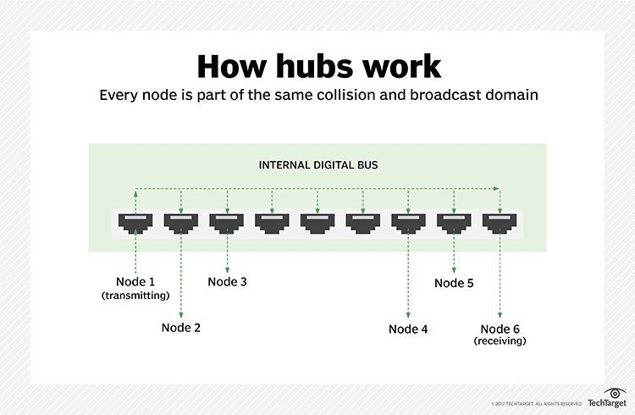

What are Gateways in Computer Network?

A gateway is a network node that forms a passage between two networks operating with different transmission protocols. The most common type of gateways, the network gateway operates at layer 3, i.e. network layer of the OSI (open systems interconnection) model. However, depending upon the functionality, a gateway can operate at any of the seven layers of OSI model. It acts as the entry – exit point for a network since all traffic that flows across the networks should pass through the gateway. Only the internal traffic between the nodes of a LAN does not pass through the gateway.

**What is network interface card (NIC)?**

A network interface card (NIC) is a hardware component without which a computer cannot be connected over a network. It is a circuit board installed in a computer that provides a dedicated network connection to the computer. It is also called network interface controller, network adapter or LAN adapter.

Purpose

* NIC allows both wired and wireless communications.
* NIC allows communications between computers connected via local area network (LAN) as well as communications over large-scale network through Internet Protocol (IP).
* NIC is both a physical layer and a data link layer device, i.e. it provides the necessary hardware circuitry so that the physical layer processes and some data link layer processes can run on it.

**Repeaters**

The first popular Ethernet medium was a copper coaxial cable known as "thicknet." The maximum length of a thicknet cable was 500 meters. In large building or campus environments, a 500-meter cable could not always reach every network device. A repeater addresses this problem.

Repeaters connect multiple Ethernet segments, listening to each segment and repeating the signal heard on one segment onto every other segment connected to the repeater. By running multiple cables and joining them with repeaters, you can significantly increase your network diameter.

**What is a router?**

A network device that forwards data packets from one network to another. A wired router, or "wired services router," is primarily used in a home or small office that has a separate Wi-Fi access point (AP). It is essentially a "wireless router without the wireless" but also tends to have more management functions as found in an enterprise-class router.

hink of a router as an air traffic controller and data packets as aircraft headed to different airports (or networks). Just as each plane has a unique destination and follows a unique route, each packet needs to be guided to its destination as efficiently as possible. In the same way that an air traffic controller ensures that planes reach their destinations without getting lost or suffering a major disruption along the way, a router helps direct data packets to their destination IP address.

In order to direct packets effectively, a router uses an internal routing table — a list of paths to various network destinations. The router reads a packet's header to determine where it is going, then consults the routing table to figure out the most efficient path to that destination. It then forwards the packet to the next network in the path.

**Twisted Pair Cable:**

It is a type of wiring in which two conductors are twisted together to form a circuit for transmission purposes. It is formed by combining two separate insulated copper wires. Metallic conducting wire present in twisted pair cable is used in the transfer of data in the form of electric signals. Twisted pair cable is the cheapest cable available among all the cables used in Local Area Network. Twisted pair cables are commonly used in data networks and wire shielding.

Advantages of Twisted Pair Cable:

* Low Cost: Twisted Pair Cable is relatively inexpensive compared to other types of cables.
* Flexibility: The cable is very flexible and easy to install, making it a popular choice for networking applications.
* Familiarity: Twisted Pair Cable is a well-established technology that has been used in networking for many years.
* Easy to Terminate: The cable is easy to terminate, making it easy to install and maintain.

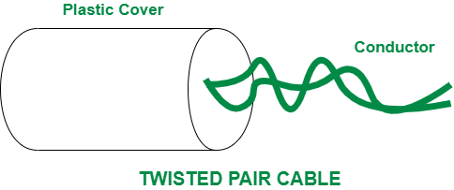

**Optical Fiber Cable**

It is a category of guided media that is used for long-distance transmission and high-performance data networking. Optical fiber cable constitutes very thin glass fibers clustered in a single cable. In optical fiber cable, glass fiber helps in transmitting the signals in the form of pulses of light. Optical fiber cables are mostly used in long-distance networks and huge volume data centers.

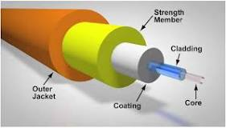

**What is Coaxial Cable ?**

A coaxial cable is an electrical cable with a copper conductor and an insulator shielding around it and a braided metal mesh that prevents signal interference and cross talk. Coaxial cable is also known as coax.

The core copper conductor is used for the transmission of signals and the insulator is used to provide insulation to the copper conductor and the insulator is surrounded by a braided metal conductor which helps to prevent the interference of electrical signals and prevent cross talk. This entire setup is again covered with a protective plastic layer to provide extra safety to the cable.

